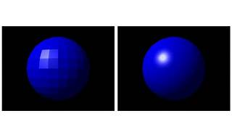

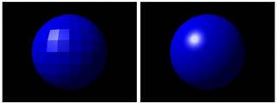

Explore

**Shader programming** involves creating small programs that run on the **GPU** to calculate lighting, color, and other visual effects during the rendering of 3D scenes. [These programs, known as shaders, transform inputs to outputs and play a crucial role in creating realistic graphics1](https://learnopengl.com/Getting-started/Shaders)[2](https://www.gamedesigning.org/learn/shaders/)[3](https://en.wikipedia.org/wiki/Shader).

Here are **five free resources** where you can learn more about shader programming:

1. [**LearnOpenGL - Shaders**](https://learnopengl.com/Getting-started/Shaders): This tutorial covers shaders, the OpenGL Shading Language (GLSL), and how to use them effectively[1](https://learnopengl.com/Getting-started/Shaders).
2. [**Shader Tutorials by Ronja**](https://www.ronja-tutorials.com/): Explore various shader topics, including compute shaders, sprite outlines, and material property blocks[4](https://www.ronja-tutorials.com/).
3. [**The Book of Shaders**](https://thebookofshaders.com/04/): Dive into interactive shader examples and learn how to run your own shaders using p5.js[5](https://thebookofshaders.com/04/).
4. [**What Are Shaders in Video Games?**](https://www.gamedesigning.org/learn/shaders/): Understand shaders’ role in games, from enhancing lighting to creating stunning visual effects[2](https://www.gamedesigning.org/learn/shaders/).
5. [**Shader - Wikipedia**](https://en.wikipedia.org/wiki/Shader): A comprehensive overview of shaders and their specialized functions in computer graphics[3](https://en.wikipedia.org/wiki/Shader).

Happy learning! 🚀🎮